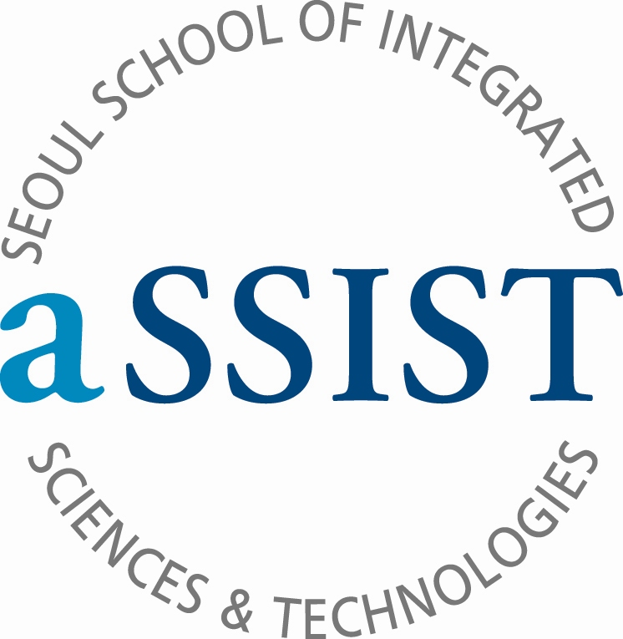

PHOTO

Application 申请书 (English/Chinese)
Please type or print in block letters in English. Your name should be indicated as it appears in your passport.
请用中/英文正确填写，您的姓名英语全拼必须与您身份证或护照上的一致。
 Master’s Program 硕士课程  Combined Master’s/Doctoral Program硕博连读 Doctoral Program博士课程
SURNAME / FAMILY / LAST NAME 姓 |  |  |  |  |  |  | FIRST / GIVEN NAME (fill out as shown in your passport) 名
SEX 性别  □ Male □ Female |  | NAME (Chinese) 中文名 |  |  |  |  |  |  |  | DATE OF BIRTH (YY/MM/DD) 生日
COUNTRY OF CITIZENSHIP / COUNTRY OF BIRTH 出生国家/国籍  / |  |  |  |  |  |  |  |  |  |  |  | PASSPORT No. 护照号
HOME ADDRESS 家庭住址 |  |  |  |  |  |  |  |  |  |  |  | ZIP CODE (邮编)
HOME PHONE 家里座机 |  |  |  |  |  |  |  |  |  |  |  | CELLULAR PHONE 手机
E-MAIL ADDRESS(PRIMARY) 个人email |  |  |  |  |  |  | E-MAIL ADDRESS(SECONDARY) 备用email
●ADEMIC EXPERIENCE 教育经历
UNIVERSITY, GRADUATE SCHOOL |  |  |  | FROM (YY/MM) |  | TO (YY/MM) |  |  | MAJOR AND DEGREE
※ If you need more space for your academic experience, please include this information in the education section of your resume.

●WORK EXPERIENCE 工作经历
COMPANY / ORGANIZATION |  |  |  | OCCUPATION / TITLE |  |  |  |  | INCLUSIVE DATE TO PRESENT  Ex) 2001.01.01 ~ 2005.12.31 (60 months)
 |  |  |  |  |  |  |  |  | ( months)
 |  |  |  |  |  |  |  |  | ( months)
Indicate which of the following tests you have taken or are scheduled to take and the date. (YY/MM/DD) 韩语水平
TOPIK |  |  | TOEIC / iBT TOEFL / IELTS |  |  |  |  |  |  |  | OTHER ( )
Score : 1 / 2 / 3 / 4 / 5 / 6 级  date : |  |  | Score :  date : |  |  |  |  |  |  |  | Score :  date :
(Valid for 2 years from test date) |  |  | (Valid for 2 years from test date) |  |  |  |  |  |  |  | (Valid for 2 years from test date)
● LANGUAGE PROFIENCY: Mark as Excellent / Good / Fair 语言能力：优秀/良好/一般
Language | Reading |  |  |  | Writing |  |  | Listening |  |  |  |  | Speaking
Korean | Excellent / Good / Fair |  |  |  | Excellent / Good / Fair |  |  | Excellent / Good / Fair |  |  |  |  | Excellent / Good / Fair
English | Excellent / Good / Fair |  |  |  | Excellent / Good / Fair |  |  | Excellent / Good / Fair |  |  |  |  | Excellent / Good / Fair
Others( ) | Excellent / Good / Fair |  |  |  | Excellent / Good / Fair |  |  | Excellent / Good / Fair |  |  |  |  | Excellent / Good / Fair
Please type or print in English or Chinese or Korean(中文/英文/韩文均可)

II PERSONAL STATEMENT (Study Plan) 个人介绍(学习计划)

• Please type the essays. Send the essays with your completed application form.
• Maximum of one A4 page in length for each answer.

1. Why did you choose this program?

2. In relation to your academic interests and personal perspectives, please describe your aptitude and motivation for this program, including your preparation for this field of study, your academic achievement and commitment. You may briefly elaborate in addition on any of your extracurricular activities or work experiences in the space below.

3. Describe in detail your study plans after entering this program.

4. How will this Master/Doctoral Degree help you to achieve your career goals? Please outline your career objectives and how this program will help you to achieve them.

Signature(签名) _____________________________________________________ Date(日期)______________________

